Project Design Phase-II
Data Flow Diagram & User Stories

Date | 15 February 2026
Team ID | LTVIP2026TMIDS89512
Project Name | Orderonthego : your on-demand food ordering solution
Maximum Marks | 4 Marks

Data Flow Diagrams:

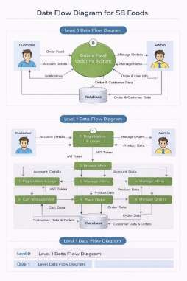

User  Stories  User Type | Functiona l  Requirem  ent (Epic) | User  Story  Number | User Story / Task | Acceptance Criteria | Priori ty | Release
Customer | Registrati on | USN-1 | As a user, I can register using email and password | Account is created and  user redirected to login/dashboard | High | Sprint-1
Customer | Authentic ation | USN-2 | As a user, I can log in securely using JWT authentication | Successful login redirects to dashboard | High | Sprint-1
Customer | Product Listing | USN-3 | As a user, I can view available food items | Food items load correctly from database | High | Sprint-1
Customer | Cart  Managem ent | USN-4 | As a user, I can add items to cart | Selected item appears in cart  with correct quantity | High | Sprint-2
Customer | Cart Managem ent | USN-5 | As a user, I can update or remove items from cart | Cart updates correctly without errors | High | Sprint-2
Customer | Order  Placemen  t | USN-6 | As a user, I can place an order | Order is stored  in database and  confirmation is shown | High | Sprint-2
User  Stories  User Type | Functiona l  Requirem  ent (Epic) | User  Story  Number | User Story / Task | Acceptance Criteria | Priori ty | Release
Customer | Order Tracking | USN-7 | As a user, I can view order status | Order status displays as Pending /  Preparing /  Delivered | Medi um | Sprint-3
Customer | Order History | USN-8 | As a user, I can view my previous orders | Past orders are displayed correctly | Medi um | Sprint-3
Admin | Product  Managem ent | USN-9 | As an admin, I can add new food items | New product appears in product list | High | Sprint-3

